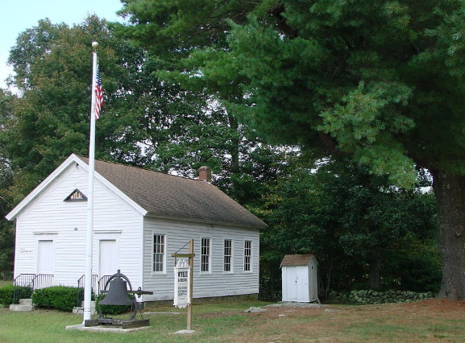
Wylie School House Renovations Committee Agenda
Monday, June 18, 2018, 6:30 pm
Wylie School House
I. Call to Order
II. Pledge of Allegiance
III. Welcome
IV. Statement of Purpose
V. Approval of Minutes
VI. Treasurer’s Report
VII. Review of presentation for BOS
Meeting on 06-26-18

VIII. Discussion of pending projects
A. Prioritization order for submission
To BOS
B. Status of electrical wiring connection
C. Cost estimates received to-date
D. Specs required for cost estimates
E. Availability of donated materials
(primer, paint, white oak lumber)
F. Other

IX. Appointment of fundraising sub-committee

X. Appointment for committee vacancy

XI. Agenda items, date and location for next
Committee meeting

X. Adjournment

