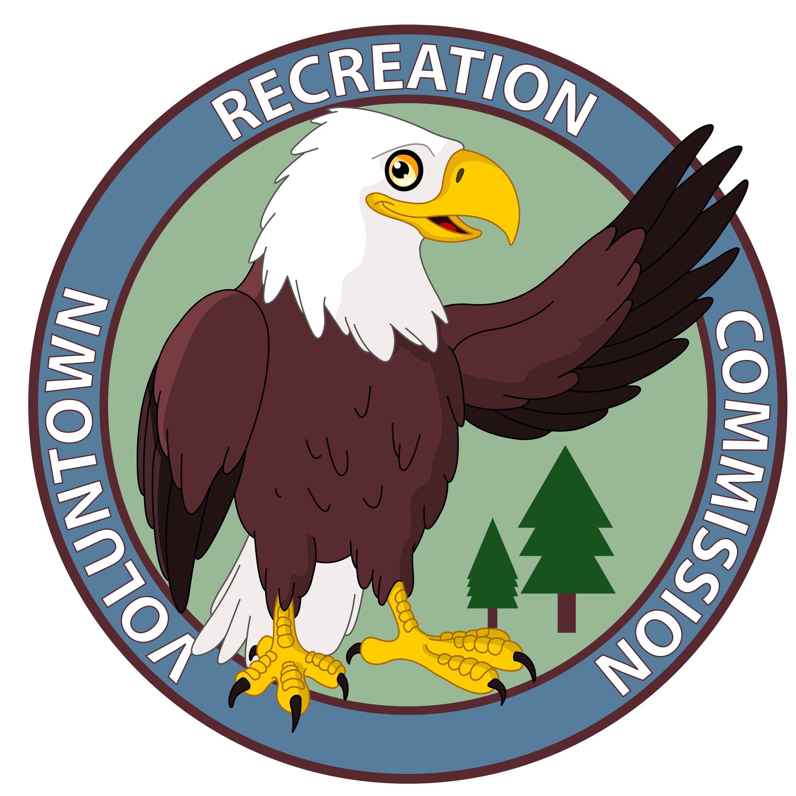
Voluntown Recreation Commission

Zumba Classes
Monday’s, Feb 6, 13, 20, 27, March 6, 13, 20, 27
6:00 pm – 7:00 pm, Voluntown Baptist Church
Ages 16 and up
Participant Registration Form

Name _______________________________________ Male/Female ___________ Age _____

Street Address ________________________________________________________________

City/Town ___________________________ State/Zip ________________________________

Email Address _________________________ Phone__________________________________

Program/Activity _____Zumba____ Fee____$5 per Class or $40 per Session______________

Payment- Cash ______________ Check _______________ Date________________________

Emergency Contact Name ______________________________________________________
Emergency Contact Phone ______________________________________________________

Special considerations/ needs (Please list allergies, medications, restrictions, etc. Add additional pages if needed): _______________________________________________________

Please read carefully and sign below
RELEASE OF LIABILITY AND ASSUMPTION OF RISK AGREEMENT This release is intended to discharge in advance the Board of Education, Town of Voluntown, the Voluntown Recreation Commission, its officers, agents and employees from and against any and all liability arising out of or connected with my participation in said classes or activities. It is understood and agreed that this waiver, release and assumption of risk is to be binding on my heirs, personal representatives, next of kin, spouse and assigns. The Voluntown Recreation Commission has made me aware, and I fully understand, that my participation in activities sponsored by the Voluntown Recreation Commission may expose me to dangers inherent in the activities that could, under normal conditions of the activities, result in my serious injury or death; notwithstanding this knowledge, I voluntarily apply and agree to participate therein. In consideration of the acceptance of this application for entry into the classes or activities listed above, I hereby waive, release and discharge any and all claims for damages for death, personal injury or property damage which I may have, or which may hereafter accrue to me as a result of my participation in said classes or activities. Further, I agree to the unreserved use of my name and/or likeness (including photographs, videotapes and other depictions) for publicizing the Voluntown Recreation Commission.

Parent or guardian must sign for youth 18 and under. Registration is not complete without signature.

Signature_______________________________________Date___________________

**For an emergency cancellation how should we contact you? (Specify email, text, call) ________________________________________________________________________

Please make checks or money orders payable to the Town of Voluntown and drop off at Voluntown Elementary School, Voluntown Town Hall, or bring the evening of class.

